G.Naveen kumar

192111635

4.CONNECTIVITY PROGRAM FOR STUDENT MARKSHEET

FORM:-

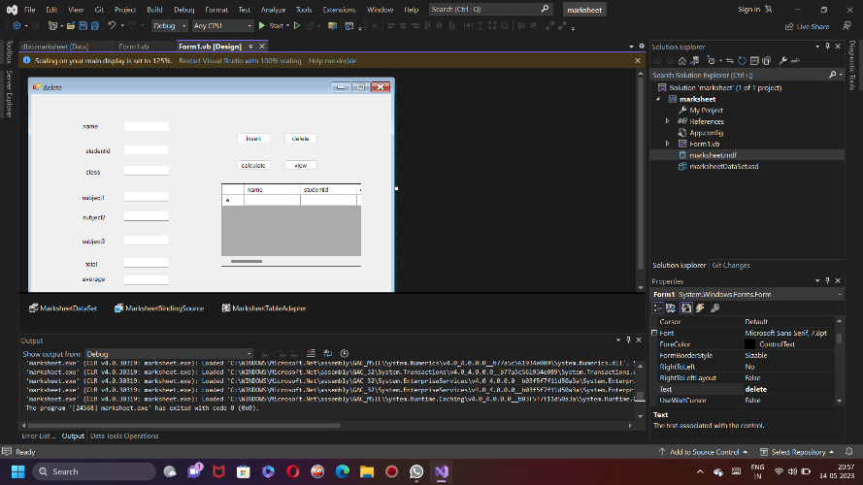

DATABASE:-

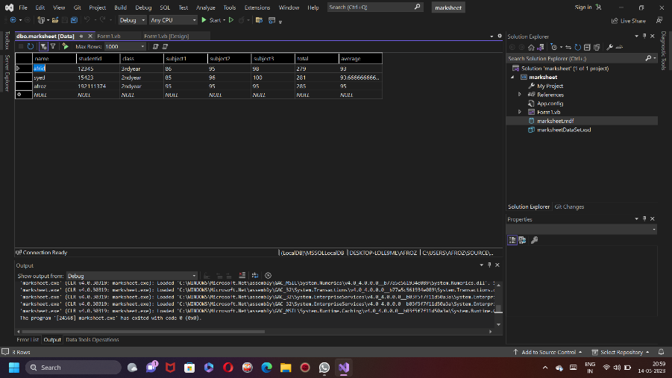

CODE:-

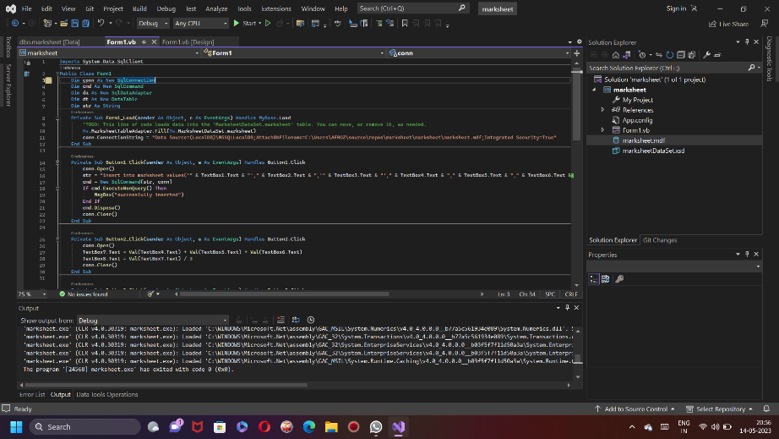

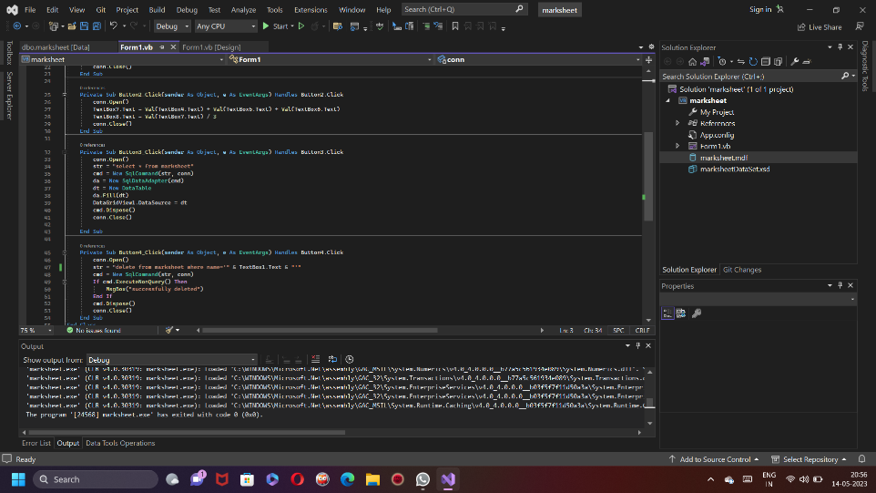

OUTPUT:-

